MechaCoders

**Team: MechaCoders**

**Iliya Marinov**

**Vasil Stanchev**

**Krasiyana Kamburova**

**Ivo Dimov**

**Angel Veselinov**

**Table of content:**

1. **Authors**
2. **Purpose**
3. **Diagram**
4. **Main steps in the implementation of the project**
5. **Game conditions**
6. **Elements**

**5.1**

**5.2 Developer-Oriented**

**5.3 Developer Environment**

**1. Authors:**

* **Iliya Marinov-** [**IMMarinov18@codingburgas.bg**](mailto:IMMarinov18@codingburgas.bg) **- Class XG**
* **Vasil Stanchev- VTStanchev18@codingburgas.bg - Class XV**
* **Krasiyana Kamburova -** [**KSKamburova18@codingburgas.bg**](mailto:KSKamburova18@codingburgas.bg) **- Class XB**
* **Ivo Dimov – IMDimov18@codingburgas.bg** **– Class XA**
* **Angel Veselinov- AVZhelyazkov18@codingburgas.bg - Class XA**

**2. Purpose:**

The aim of our project is faster and easier organization of data of students, staff and teachers in the school.

**3. Diagram:**

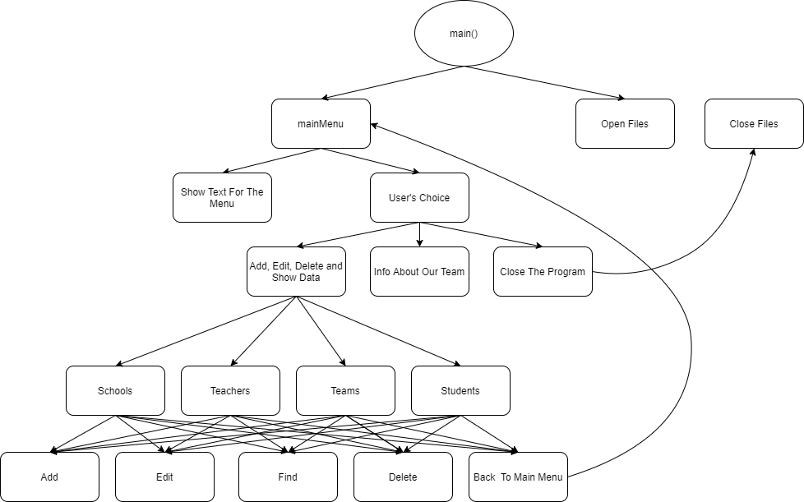

**4. Main steps in the implementation of the project:**

* Defining the main idea
* Defining the purpose of the project
* Implementing the project by writing code

The application is written in C++

**5. Elements:**

**•** The structure of the application is as easy to use as possible.

**5.1:**

**•** Our application designed for easy data collection.

**5.2 Developer-Oriented:**

* The biggest hurdle to rapid development is often not your development process, but how much time you spend focusing on the business logic of the function you are working on.

**5.3 Developer Environment:**

* *An example of an easy-to-work-with development environment:*

1. A developer clones a GitHub repo
2. He or she runs a couple of commands from a make file
3. Tests run
4. The application comes up and is accessible
5. Code changes are apparent in the running application